

Please visit our website at www.farmvilleva.com, then click on “departments” / Farmville Police Department for a more detailed look at parking restrictions and regulations, laws that commonly affect college students, and a safety and crime prevention guide to assist you in making your college experience the best it can be.

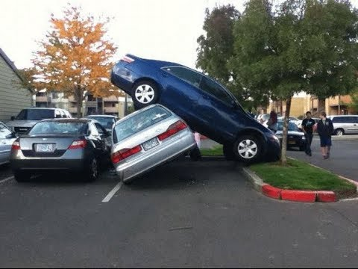
Parking

- Parking is allowed in designated areas only, during designated times, and for prescribed time periods.
- Violations of the parking ordinance will result in a parking ticket, and can result in your vehicle being towed.
- Parking decals and hangtags must be displayed and are valid from April 15 of the current year to April 15 of the next year. They are available for purchase at the Town Office.
- If parking in a metered spot you must pay to park or face a fine and the possibility of having your vehicle towed.
- Do not park in a handicap parking spot or the yellow cross hatched area surrounding a handicap spot unless you have a valid handicap placard or tag.
- Any questions regarding parking can be forwarded to the Longwood Police Department for campus issues or the Town of Farmville Police Department.
- Resident parking is for residents of that particular house, not resident students looking for a place to park. Resident parking on campus is different from resident parking throughout the town. Be aware of the locations in which you see the different “Resident Parking” signs.

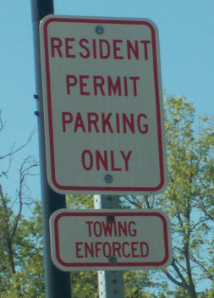 TOWN OF FARMVILLE resident parking only in these areas.
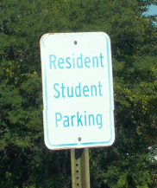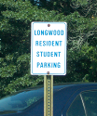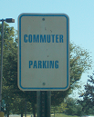
Longwood University resident/commuter students may park in areas with these signs.

Crime Prevention and Safety

- In general stay aware of your surroundings. If you see something suspicious report it, and get to a safe location.
- When walking don’t travel alone. Travel in well lit and regularly used areas. Let people know when you are leaving and when to expect you so if you have an emergency and can’t seek help someone will know to look for you in a timely fashion.
- Make sure to have a charged cell phone available but do not commit all of your attention to the device.
- Keep your doors locked and windows closed if practical.

- When choosing an area to park or stop avoid dimly lit or out of the way areas.
- Should you suspect that someone is following you look for a well lit area with people present and seek help.
- When parking, make sure you choose an open and well lit area. Remember not to leave valuables in your car, including your keys. Lock your vehicle, and upon returning to your car, check in and around the vehicle for any suspicious persons or items.
- Don’t text and drive! Or Facebook and drive, or snap chat and drive, or tweet and drive, or yik yak and drive. It is a good idea not to use your phone while driving.

Protection of Student’s Personal Property

- Keep your residence secure at all times. Windows and doors should be locked even when you are home.
- Protect your personal information
- Avoid personalizing or decorating your residence with information or decorations that indicate the number of tenants and whether or not you are currently home.
- Before allowing anyone into your residence make sure you know the person or persons or you can verify the purpose for which they are present, i.e. contacting the repair company or landlord to ensure that a repair person or maintenance person is scheduled.
- If you encounter someone that your perceive to be suspicious call the police department.
- The periods during which college is not in session are no secret. Criminals wishing to take advantage of college students know when to look for crimes of opportunity. Don’t leave valuables in your residence when on break or away for extended periods. TVs, computers, video game systems, DVDs, iPods, cell phones, and CDs are a favorite commodity for criminals to steal.

- Keep your bike locked when not in use. Record the serial number in case of theft. Register your bike with Longwood.
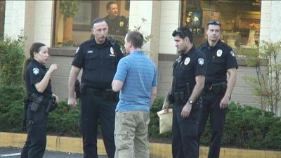

Living and interacting in public while off Campus
- Most incoming College freshman, and almost every returning student, is over the age of 18. Therefore, you are an adult. With age comes responsibility. There are times to celebrate and cut loose with friends, but the rules are never negated.
- The Town of Farmville has a noise ordinance. Vehicles, parties, and even individuals can disturb or annoy the public.
- Loitering, urinating in public, and trespassing will not be tolerated.
- Fireworks are illegal in town. No exceptions. Snakes and sparklers are acceptable.
- The police department is keenly aware of off campus party locations. Underage consumption of alcohol is illegal. If you are of age and consume alcohol in a responsible fashion, there is no problem. However, if you drink in public, become intoxicated in public, cause a disturbance, supply someone underage with alcohol, destroy private property or possess alcohol underage you can and will be charged with a crime.
- Upon the consumption of alcohol the likelihood that an argument or confrontation will turn violent is significantly higher. Therefore the police department will not tolerate these acts and swift action on our part will be taken to arrest and charge all individuals involved.
- Just as Longwood students wish to keep their personal property protected and free from harm, so do the rest of the residents of the Town of Farmville. Destruction of property will result in arrest, and the expectation through court for the victim to have the property repaired or replaced at the cost of the offender.

Contact Information

- Farmville Police Department
  - 116 North Main Street Farmville, VA 23901 Non-emergency (434-392-3332)
- Longwood University Police Department
  - 304 Brock Commons, Farmville, VA 23909 Non-emergency (434-395-2398)
- Prince Edward Sheriff’s Office
  - 124 North Main Street Farmville, VA 23901 Non-emergency (434-392-8101)

www.farmvilleva.com
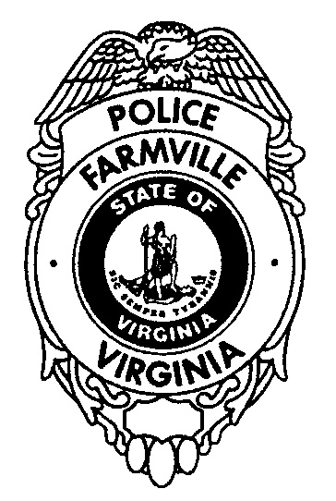
During the upcoming weeks, officers from the Farmville Police Department will be in the neighborhoods surrounding the Longwood campus to speak with students, tenants, and local residents concerning issues facing these neighborhoods. From speaking with students and residents in the past, some of the things that cause the biggest tensions in the neighborhoods are parking issues, increased traffic, and loud noise. We want you to enjoy your college experience as well as be contributing members of the community. We also want you to take responsibility for yourselves and your friends. One of the complaints we get from students in off-campus housing is in regard to unwanted subjects at their social events. If you are planning a social event off-campus, it would serve you well to designate someone to check student’s ids at the door to the event. This will help you to control the amount of people in the residence at one time, (some renters will have clauses in their leases that limit the number of people that may be in the residence at one time. Check your individual lease agreements for such restrictions) and help you keep unwanted subjects out of your events. These are things you can do to help make sure that your friends can enjoy the events and remain as safe as possible while having a good time.

Curtis L. Davis, Jr.
Chief of Police

116 N. Main Street – PO Box 24 – Farmville, VA 23901
Phone: 434.392.9259 – Fax: 434.392.9901 – Internet: www.farmvilleva.com

